Microservices: Account & Loan Services
Week 5
Folder Structure:
Base folder : c:\<6393941>\microservices\
Account service: c:\<6393941>\microservices\account\
Loan Service: c:\<6393941>\microservice\loan\

Account Service:
1.Spring Initializer Setup:
Group:com.cognizant
Artifact:account
Dependencies:
Spring web
Spring Boot DevTools
Endpoint
Method:Get
URL:http://localhost:8080/accounts/{12345}

AccountController.java:
@RestController
@RequestMapping("/accounts")
public class AccountController {

@GetMapping("/{number}")
public Account getAccount(@PathVariable String number) {
return new Account(number, "savings", 234343);
}

static class Account {
private String number;
private String type;
private double balance;

public Account(String number, String type, double balance) {
this.number = number;
this.type = type;
this.balance = balance;
}

public String getNumber() { return number; }
public String getType() { return type; }
public double getBalance() { return balance; }
}
}

Pom.xml file for Account Microservice:
<project xmlns="http://maven.apache.org/POM/4.0.0"
xmlns:xsi="http://www.w3.org/2001/XMLSchema-instance"
xsi:schemaLocation="http://maven.apache.org/POM/4.0.0
http://maven.apache.org/xsd/maven-4.0.0.xsd">
<modelVersion>4.0.0</modelVersion>

<groupId>com.cognizant</groupId>
<artifactId>account</artifactId>
<version>0.0.1-SNAPSHOT</version>
<name>account</name>
<description>Account Microservice</description>
<packaging>jar</packaging>

<parent>
<groupId>org.springframework.boot</groupId>
<artifactId>spring-boot-starter-parent</artifactId>
<version>3.2.0</version>
<relativePath/> <!-- lookup parent from repository -->
</parent>

<properties>
<java.version>17</java.version>
</properties>

<dependencies>
<!-- Web Dependency -->
<dependency>
<groupId>org.springframework.boot</groupId>
<artifactId>spring-boot-starter-web</artifactId>
</dependency>

<!-- DevTools -->
<dependency>
<groupId>org.springframework.boot</groupId>
<artifactId>spring-boot-devtools</artifactId>
<scope>runtime</scope>
</dependency>

<!-- Test -->
<dependency>
<groupId>org.springframework.boot</groupId>
<artifactId>spring-boot-starter-test</artifactId>
<scope>test</scope>
</dependency>
</dependencies>

<build>
<plugins>
<!-- Spring Boot Maven Plugin -->
<plugin>
<groupId>org.springframework.boot</groupId>
<artifactId>spring-boot-maven-plugin</artifactId>
<version>3.2.0</version>
</plugin>
</plugins>
</build>
</project>

AccountApplication.java:
package com.cognizant.account;
import org.springframework.boot.SpringApplication;
import org.springframework.boot.autoconfigure.SpringBootApplication;

@SpringBootApplication
public class AccountApplication {
public static void main(String[] args) {
SpringApplication.run(AccountApplication.class, args);
}
}
Output:
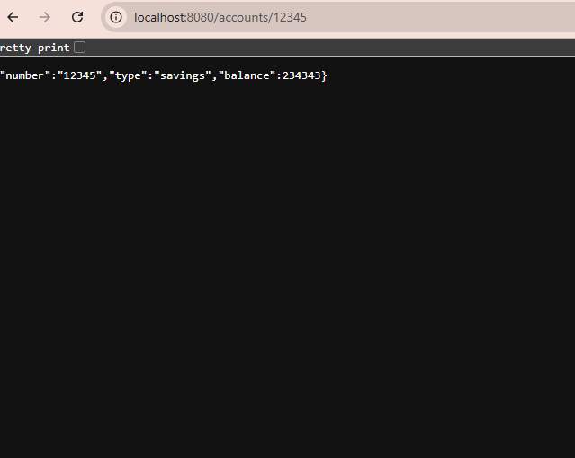

Loan Service:

Spring Initializer Setup:
Group:com.cognizant
Artifact:loan
Dependencies:
Spring Web
Spring Boot DevTools
URL: URL:http://localhost:8081/accounts/{1234}

LoanController.java:
@RestController
@RequestMapping("/loans")
public class LoanController {

@GetMapping("/{number}")
public Loan getLoan(@PathVariable String number) {
return new Loan(number, "car", 400000, 3258, 18);
}
static class Loan {
private String number;
private String type;
private double loan;
private double emi;
private int tenure;
public Loan(String number, String type, double loan, double emi, int tenure) {
this.number = number;
this.type = type;
this.loan = loan;
this.emi = emi;
this.tenure = tenure;
}
public String getNumber() { return number; }
public String getType() { return type; }
public double getLoan() { return loan; }
public double getEmi() { return emi; }
public int getTenure() { return tenure; }
}
}
Pom.xml file for Loan Service:
<project xmlns="http://maven.apache.org/POM/4.0.0"
xmlns:xsi="http://www.w3.org/2001/XMLSchema-instance"
xsi:schemaLocation="http://maven.apache.org/POM/4.0.0
http://maven.apache.org/xsd/maven-4.0.0.xsd">
<modelVersion>4.0.0</modelVersion>
<groupId>com.cognizant</groupId>
<artifactId>loan</artifactId>
<version>0.0.1-SNAPSHOT</version>
<name>loan</name>
<description>Loan Microservice</description>
<packaging>jar</packaging>
<parent>
<groupId>org.springframework.boot</groupId>
<artifactId>spring-boot-starter-parent</artifactId>
<version>3.2.0</version>
<relativePath/> <!-- lookup parent from repository -->
</parent>
<properties>
<java.version>17</java.version>
</properties>
<dependencies>
<!-- Web Dependency -->
<dependency>
<groupId>org.springframework.boot</groupId>
<artifactId>spring-boot-starter-web</artifactId>
</dependency>
<!-- DevTools -->
<dependency>
<groupId>org.springframework.boot</groupId>
<artifactId>spring-boot-devtools</artifactId>
<scope>runtime</scope>
</dependency>

<!-- Test -->
<dependency>
<groupId>org.springframework.boot</groupId>
<artifactId>spring-boot-starter-test</artifactId>
<scope>test</scope>
</dependency>
</dependencies>

<build>
<plugins>
<!-- Spring Boot Maven Plugin -->
<plugin>
<groupId>org.springframework.boot</groupId>
<artifactId>spring-boot-maven-plugin</artifactId>
<version>3.2.0</version>
</plugin>
</plugins>
</build>
</project>
LoanApplication.java:
package com.cognizant.loan;
import org.springframework.boot.SpringApplication;
import org.springframework.boot.autoconfigure.SpringBootApplication;

@SpringBootApplication
public class LoanApplication {
public static void main(String[] args) {
SpringApplication.run(LoanApplication.class, args);
}

}
Output:
